**Ci/cd with Jenkins, git, maven, tomcat, sonarqube and nexus**

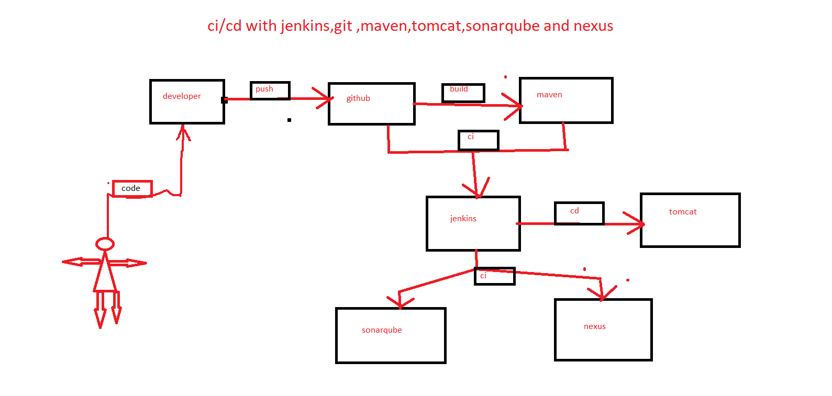

. launch two servers Jenkins and tomcat



. launch another two instances with 2 cup’s.



.start Jenkins service, tomcat service, sonarqube and nexus

. install sonar scanner plugin

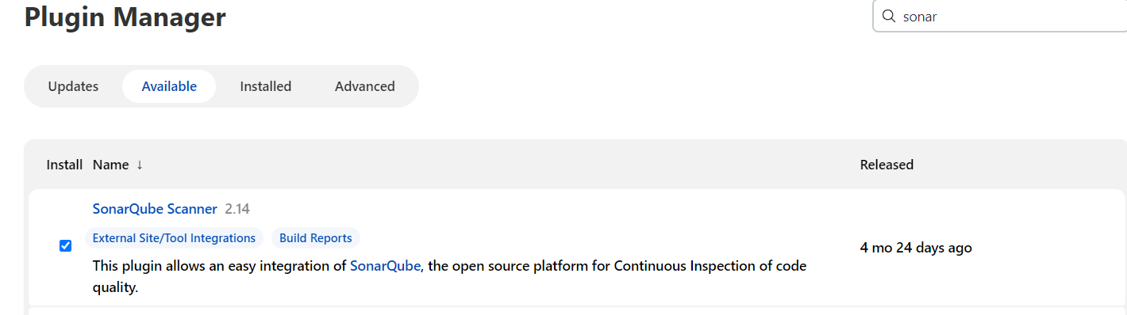

.add sonarqube token on Jenkins dashboard

🡺manage Jenkins🡺configuresystem🡺